***UTAH STATE UNIVERSITY***

NAME: CODYJ.MESEROLE, SUPRATIK CHANDA

ASSIGNMENT NUMBER:2

ASSIGNMENT DUE DATE:09/06/2018

COURSE NAME:MIS 6230

1. List all columns and all rows from the StockData table.

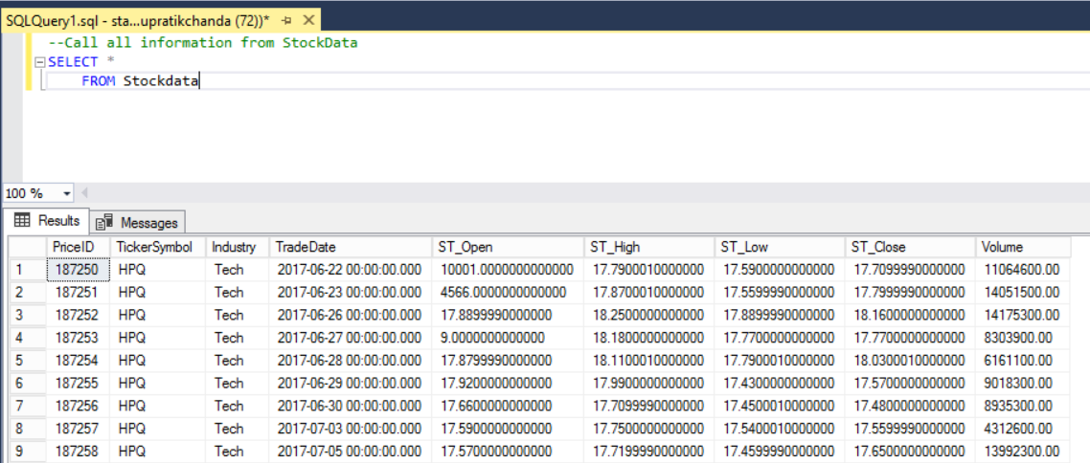

2. List the TickerSymbol, Industry, TradeDate and the Volume columns from the StockData table.  List all rows.

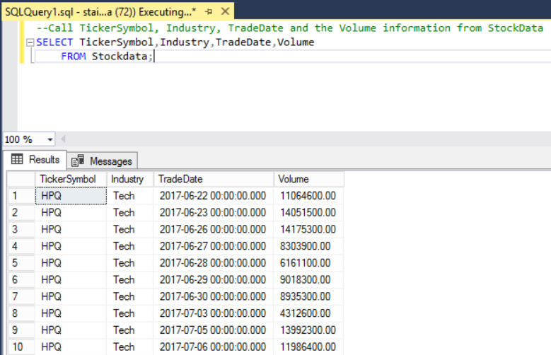

3. List the TickerSymbol, Industry, TradeDate and the Volume columns from the StockData table.  List only the rows that have a volume of more thirty million shares traded.

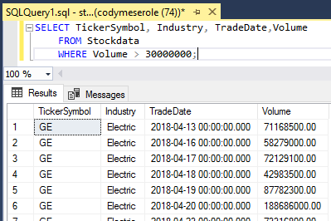

4. List the TickerSymbol, Industry, TradeDate and the Volume columns from the StockData table.  List only the rows that have a volume of more thirty million shares traded.  Arrange the answer in TickerSymbol order.  This means for example that British Petroleum should appear before Sunoco.

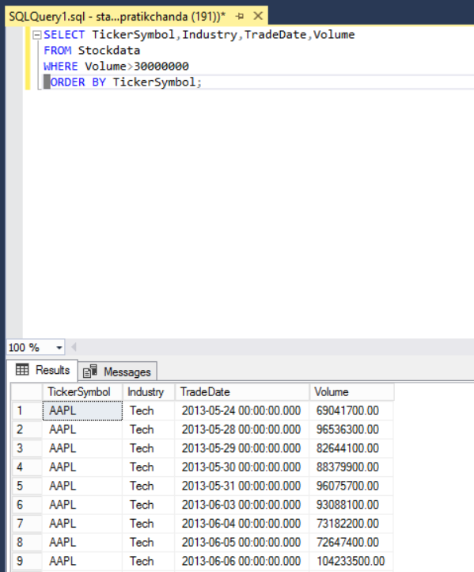

5. List the TickerSymbol, Industry, TradeDate and the Volume columns from the StockData table.  List only the rows that have a volume of more thirty million shares traded.  Arrange the answer in TickerSymbol order and then in TradeDate order.  This means that for a given stock, trading days should appear in chronological order.

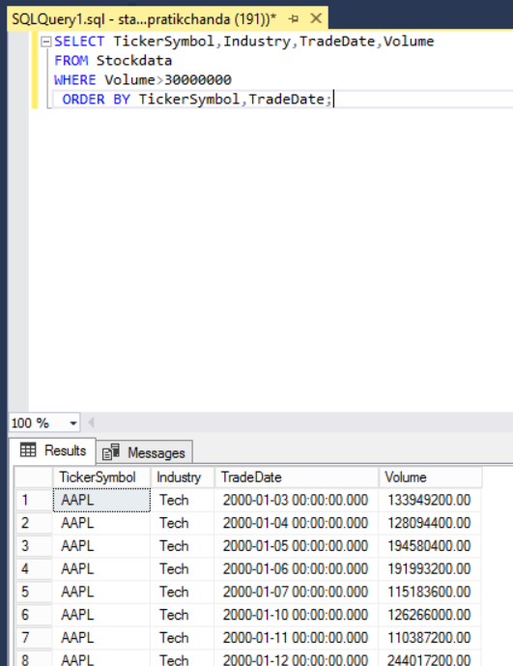

6. List the TickerSymbol, Industry, TradeDate, the opening stock price and the closing stock price.  List only those trading days that occurred in the year 2017.  Arrange the answer in order of the trade dates which means that for a given stock, trading days should appear in chronological order.

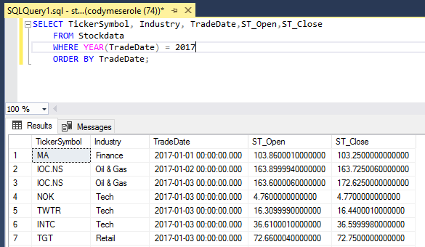

7. List the TickerSymbol, Industry, TradeDate, the opening stock price and the closing stock price.  List only those trading days that occurred in the year 2017.  Arrange the answer in order of the industry, the ticker symbol, and then by the trade dates.  Please use the "greater than" and "less than" operators for this answer.

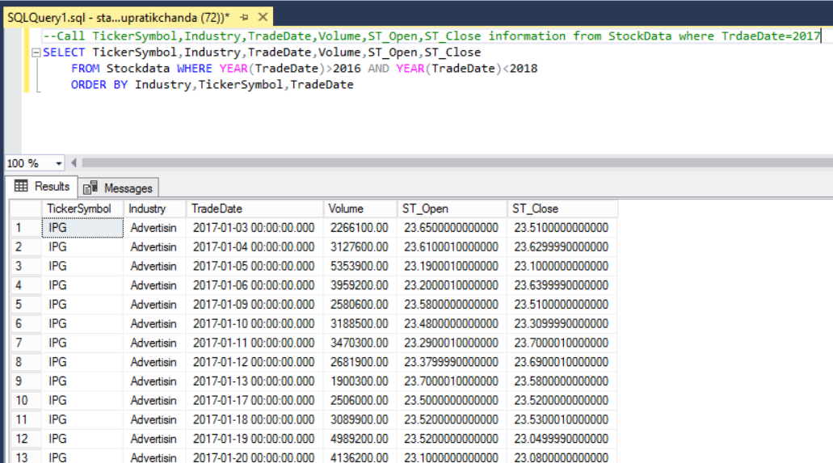

8. List the TickerSymbol, Industry, TradeDate, the opening stock price and the closing stock price.  List only those trading days that occurred in the year 2017.  Arrange the answer in order of the industry, the ticker symbol, and then by the trade dates.  Please use "between" for this answer.

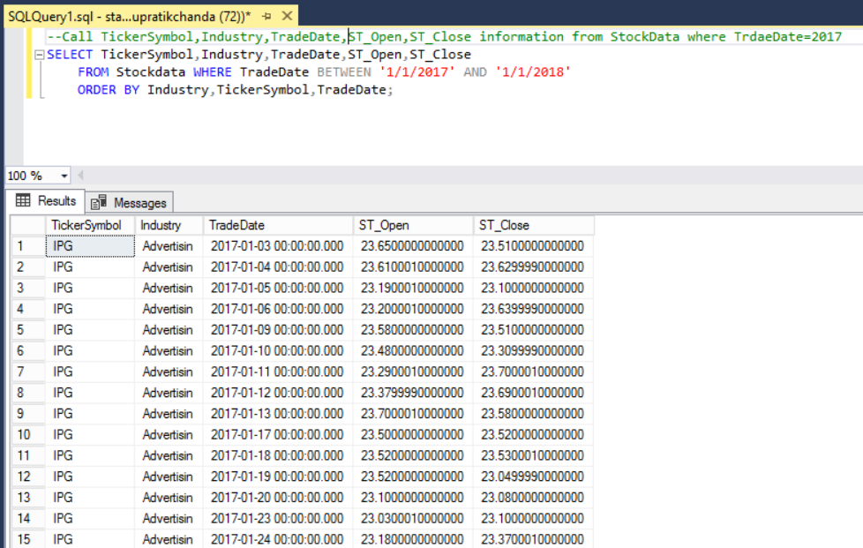

9. List the TickerSymbol, Industry, TradeDate, the opening stock price and the closing stock price.  List only stocks that include the word "oil" in the industry description.  Arrange the answer in order of the industry, the ticker symbol, and then by the trade dates.

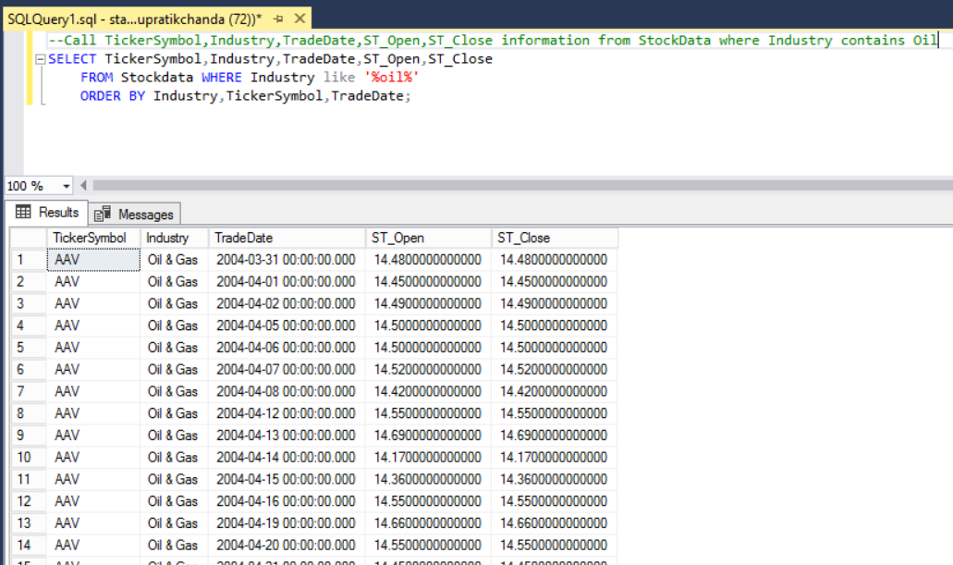

10. List the TickerSymbol, Industry, TradeDate, the opening stock price and the closing stock price.  List only stocks that do not include the word "oil" in the industry description.  Arrange the answer in order of the industry, ticker symbol, and then by the trade dates.

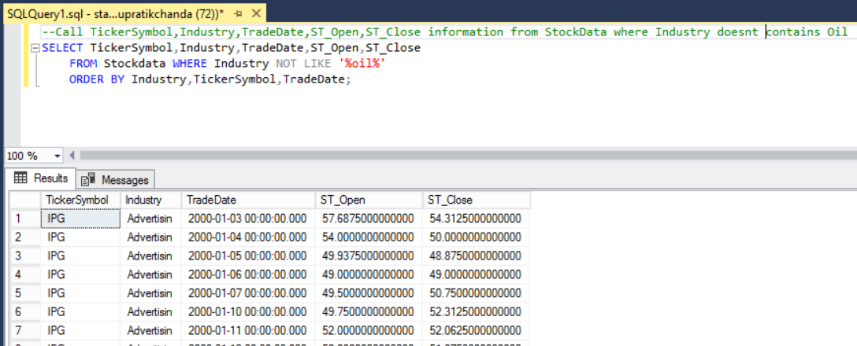n

11. List the TickerSymbol, TradeDate and the closing stock price.  List only Microsoft tuples that occurred between January 1, 2006 and June 1, 2018.  Arrange the answer in order of the ticker symbol, trade dates and then the closing price.

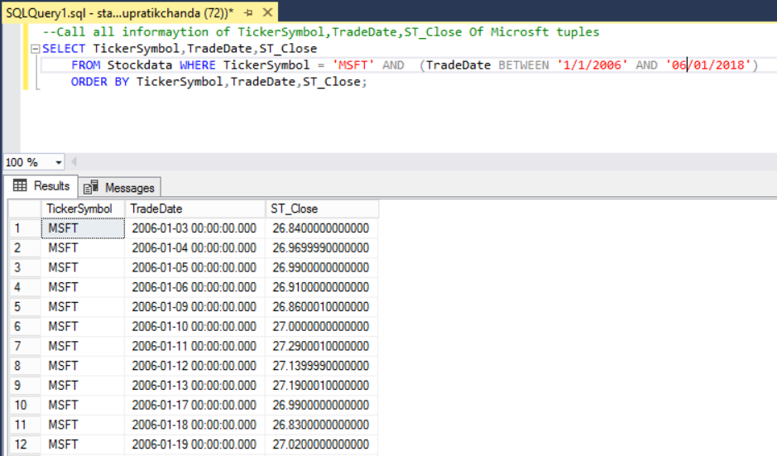

12. List the TickerSymbol, TradeDate and the closing stock price.  List only Microsoft tuples that occurred in on dates other than the range January 1, 2006 to June 1, 2018.  Arrange the answer in order of the ticker symbol, trade dates and then the closing price.

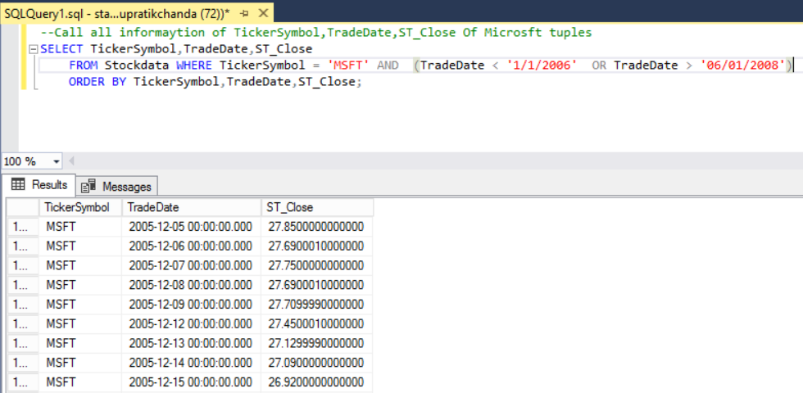

13. List the TickerSymbol, Industry,TradeDate, the opening price and the closing stock price.  List only the ‘COP’ and ‘XOM’ ticker symbols.  Arrange the answer in order of the ticker symbol, Industry and the trade dates.

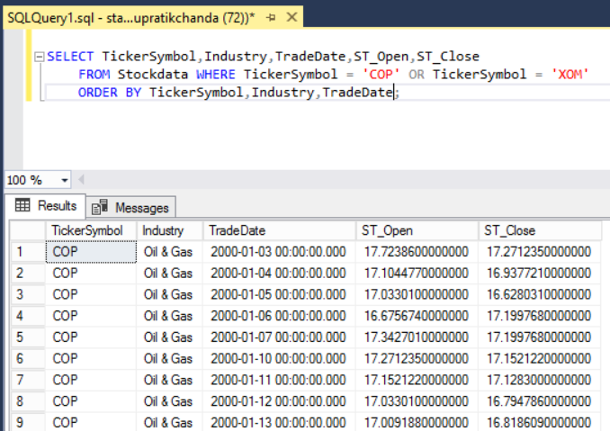

14. List the Price ID of all stocks that have a volume of 0.  List the Price IDs in descending order.

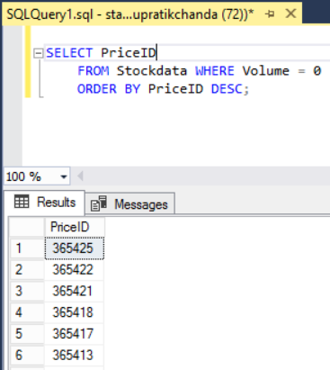

15. Return all attributes for stocks that have a closing price within 24 and 25 dollars.  List the closing prices in descending order.

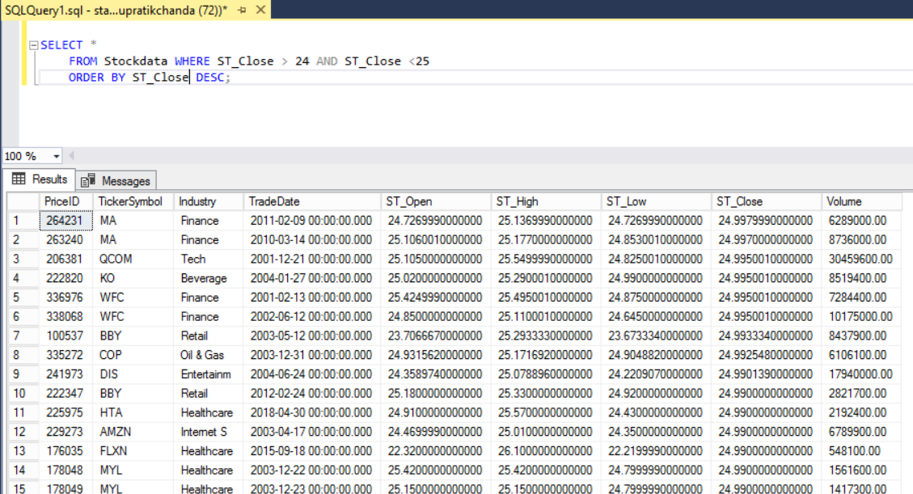

16.  Return all attributes for stocks that have been traded in the month of June in 2018.  List the trade date in descending order.

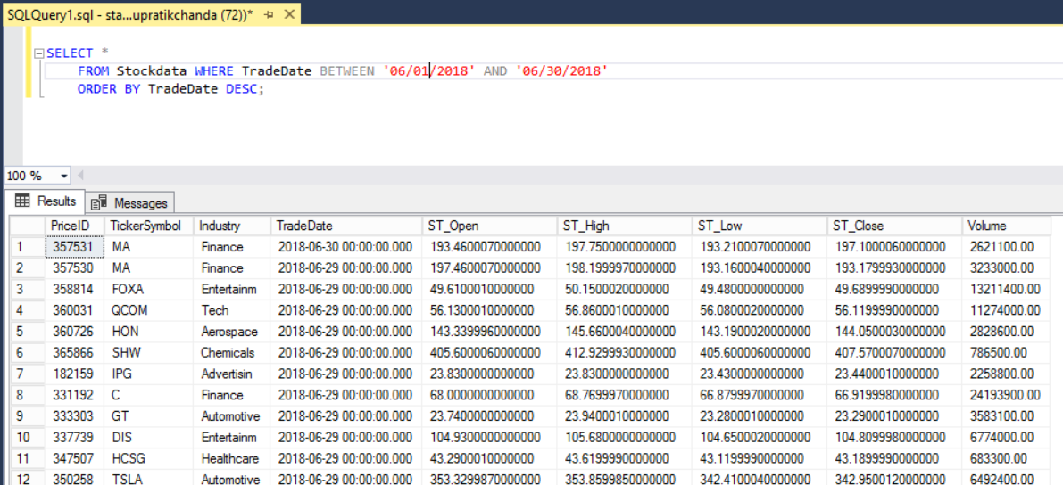

17. List the price ID, opening price, and closing price of all stocks who have an opening price smaller than 120 dollars and a closing price greater than 120 dollars.  List the opening and closing prices in ascending order.

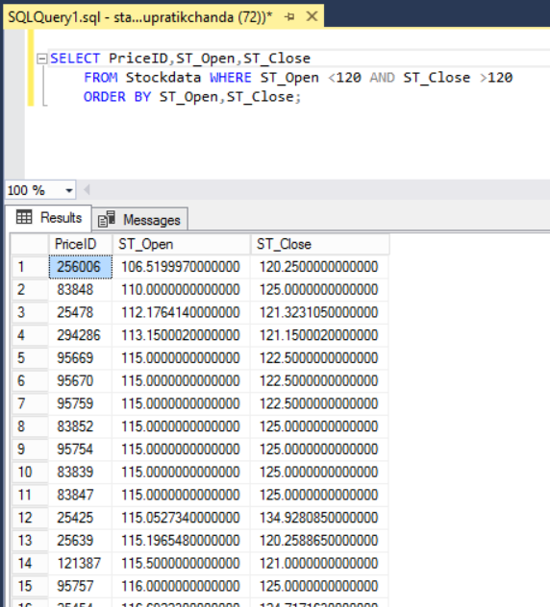

18. List the price ID, stock high and stock low of all stocks that have a stock high above 130. Also list the same information for all stocks that have a stock low below 5.  List the high and low stocks by ascending order.

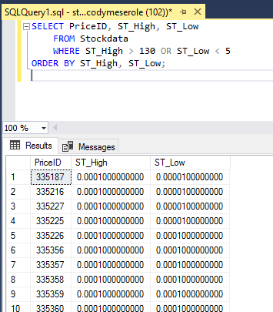

19. List the trade dates and low stock prices of all stocks that were traded in 2017.  List the trade dates in ascending order.

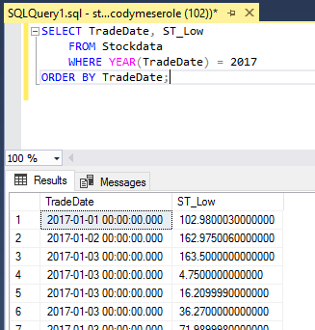

20. List the sum of all the low stock prices that are above 60 dollars.  Call it TotalLowStockPriceOfStocksUnder60.

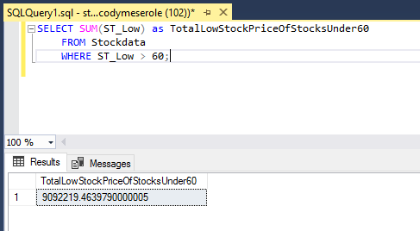

21. List the highest Price ID with a low stock price under 80 dollars.

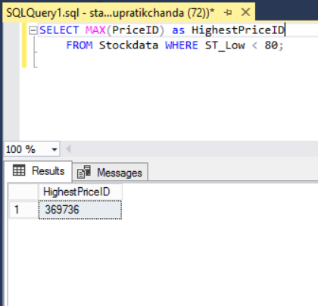

22. List the earliest trade date of the stock that ended up having a high over 100 dollars.  Call it EarliestTradeDateWithHighOver100.

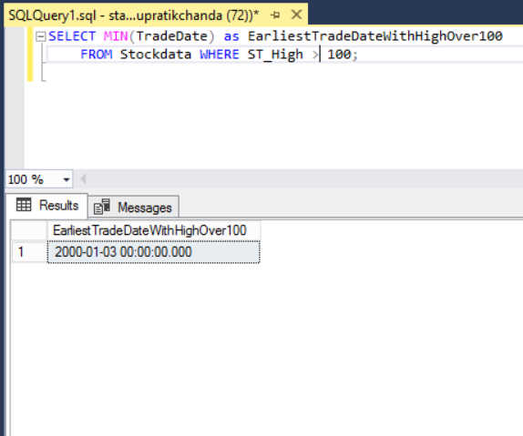

23. List the most recent trade date of a stock that ended up having a low under 5 dollars.  Call it MostRecentTradeDateWithLowUnder5.

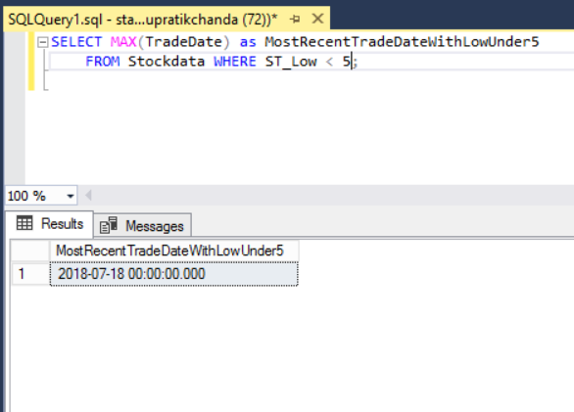

24. List the Price ID and TradeDate and stock high of all stocks that were traded before October 3rd, 2017 and had a stock high over 125 dollars. List the stock highs in descending order.

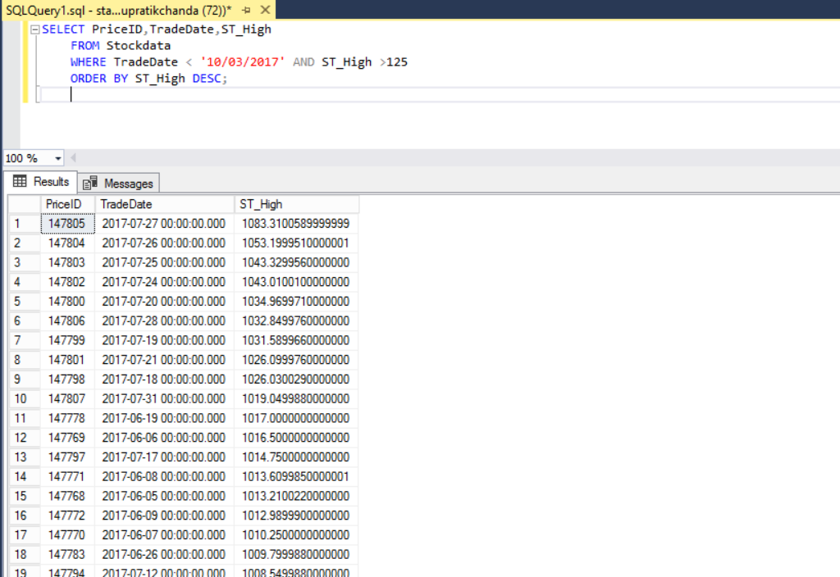

25. List the trade dates, stock highs and stock lows of all stocks that either had a stock high over 130 dollars and were traded before December 31st, 2014, or stocks that were traded after December 31st 2017 and had a stock low below 5 dollars.  List the stock highs and lows in descending order.

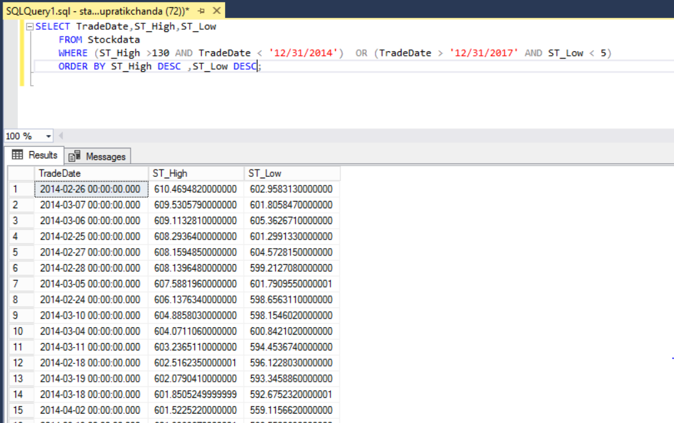

26. List the Price IDs and stock highs over 130 dollars rounded to the nearest penny.

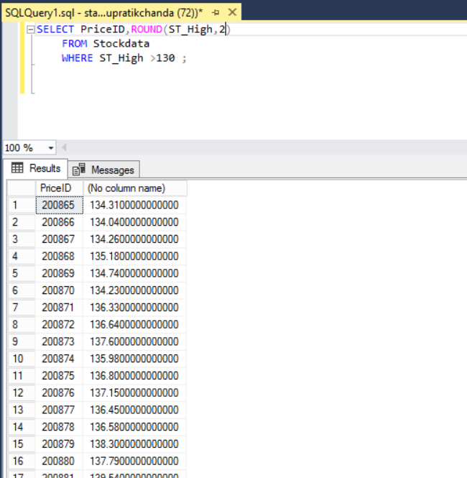

27. Return all attributes for stocks that have the MSFT ticker symbol and have a high stock price below 20 dollars or a low stock price above 50 dollars.  List the high and low stock prices in ascending order.

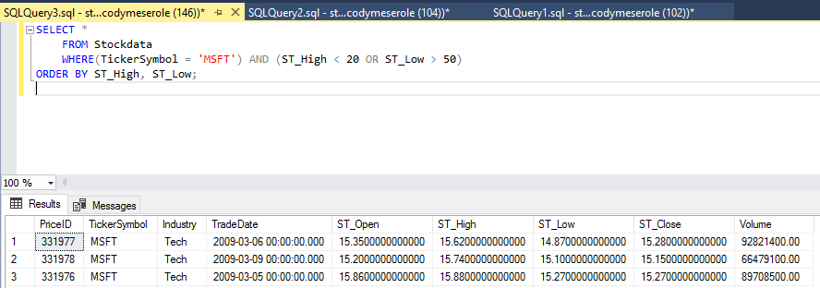

28. List the Price ID's in descending order of all the stocks that close with a price greater than 90 dollars and less than 100 dollars.

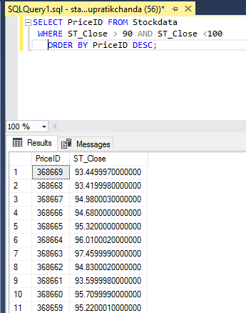

29. List the trade dates in descending order and open price in ascending order of all the stocks that open with a price greater than the average open price.

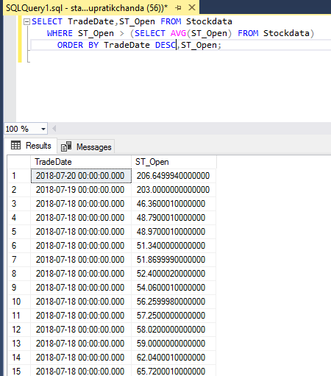

30. List the volumes in descending order of all the stocks that have an opening price greater than or equal to 100 but with a closing price not equal to 120 dollars.

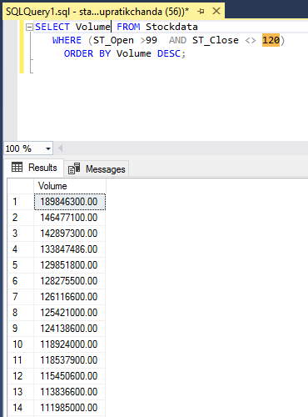

31. List the Price ID's in ascending order and the open prices of all the stocks that have an open price between 20 and 21 dollars.

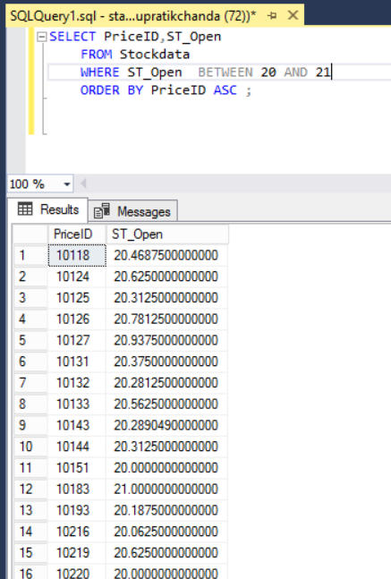

32. List the closing prices in descending order of all the closing stock prices that were below 10 dollars and were traded before January 1st, 2018.

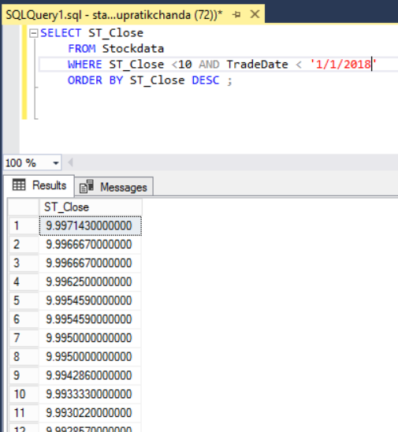

33. List the trade dates in descending order and open price in ascending order of all the stocks that open with a price greater than the average open price.

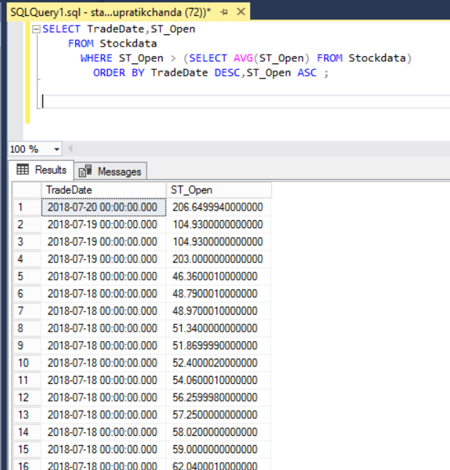

34. List the number of stocks that have an opening price of 70 dollars and were traded in 2017. Call it NumberOfOpeningPricesOf70In2017.

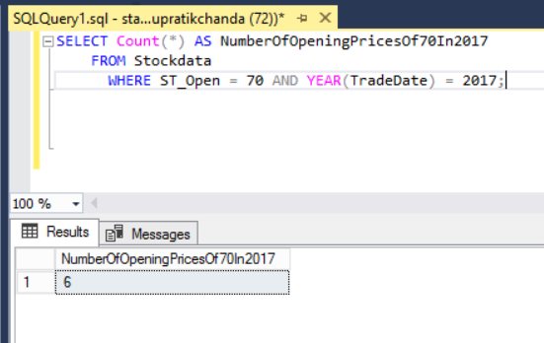

35. List the number of stocks that have a greater than average high price and were traded on March 9th, 2017. Call it NumberOfStocksAboveAverageHighIn2017.

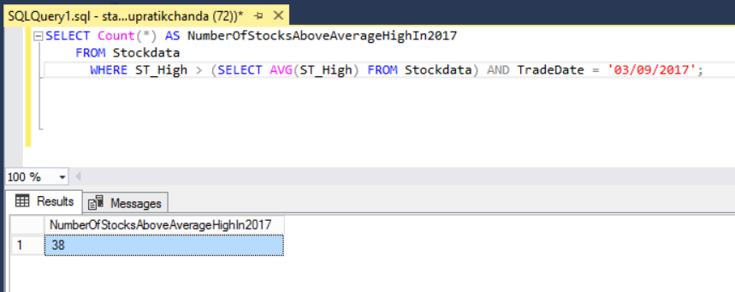

36. List the highest high price of all the stocks that have been traded in 2017 and have a low price less than 100 dollars.

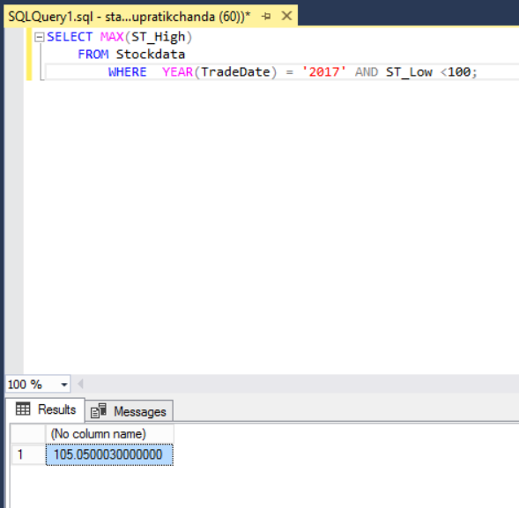

37. List the number of trade dates of stocks that were traded in the month of August in 2017.

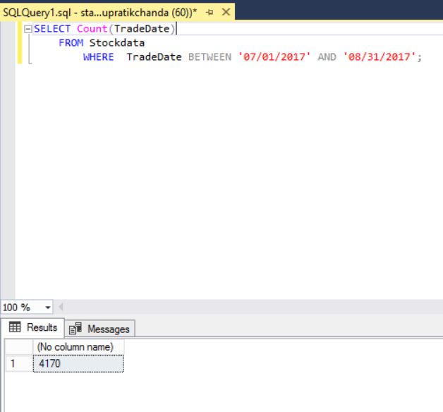

38. List the industry and the number of different companies in each industry.

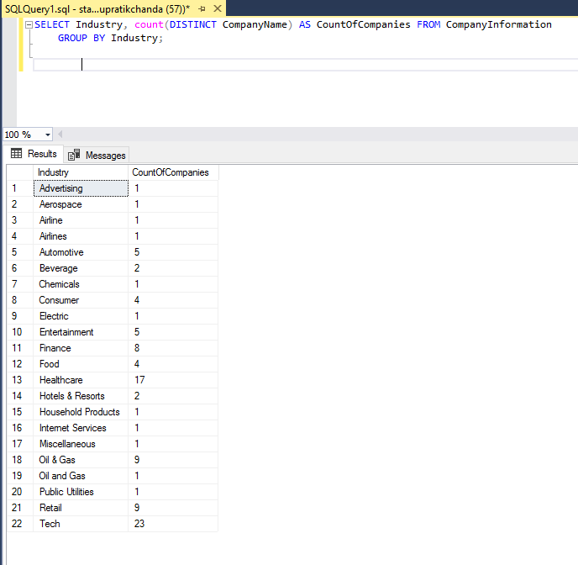

39. List the industry and the number of different companies in each industry. Put the answer in order of most stocks to least stocks.

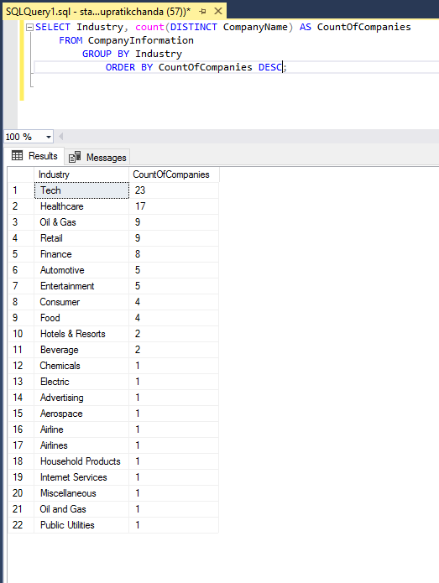

40. List the industry and the number of different companies in each industry for only those industries that have more than three companies.

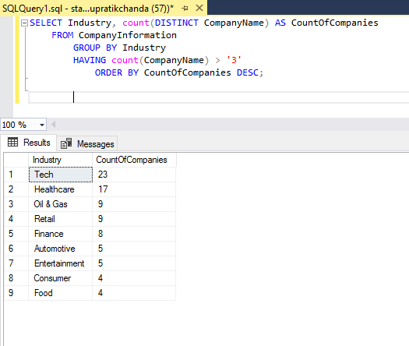

41. List the ticker symbol and the average closing for a stock that has the largest average closing price.

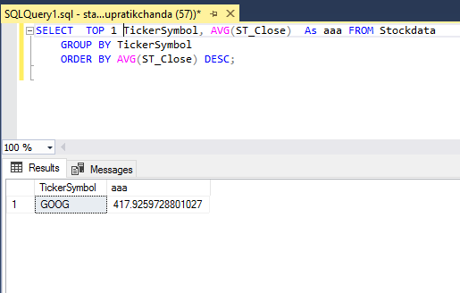

42. List the price ID and the high stock price of the two stocks with the most expensive high prices that are still less than $ 100.

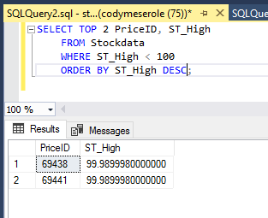

43. Add a new row to the Stock Data table. This stock should have the Microsoft ticker symbol (MSFT) in the Tech Industry. The stock was traded on July 19, 2018. It had an opening price of 104.93, a high price of 105.31, a low price of 103.89, a closing price of 104.4, and a volume of 40,171,600.

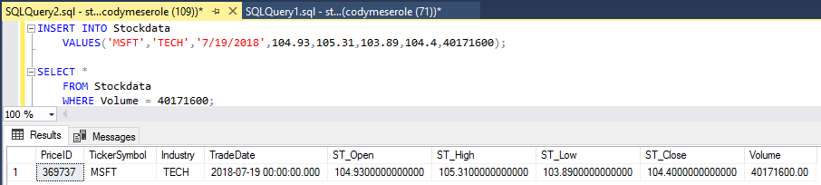

44. It’s January 30, 2019 and you need to add information to the Stock Data table for Microsoft on that date. You have to wait until the end of the day before you can put any of the prices because you don't know the closing price yet. For now just add Microsoft's trade date, Industry, and ticker symbol to the table.

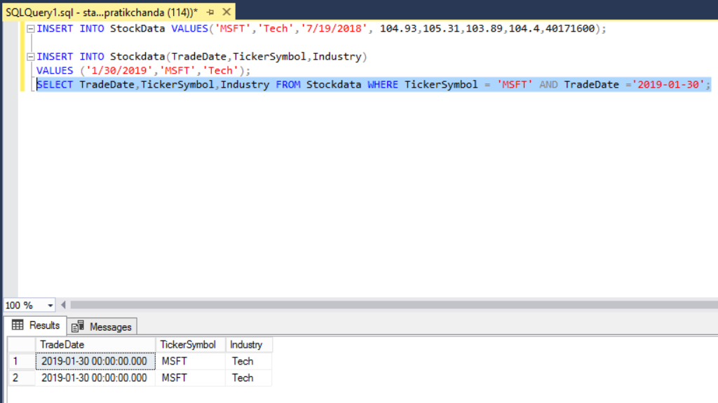

45. Remove all the rows of stocks that were traded before January 1st, 2000 for Microsoft.

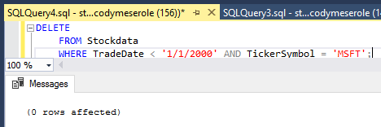

46. Make a change for the Microsoft row for April 2nd, 2018. Change the opening stock price to 90.47, the high price to 90.88, the low price to 87.51, and the closing stock price to 88.52, and the volume to 48,515,400.

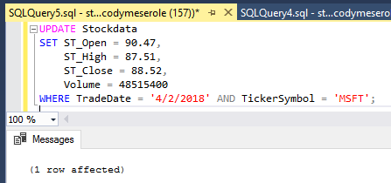

47. From the stock data table please list the ticker symbol, date, opening and closing stock prices, and day type of all stocks that were traded on a Holiday in 2018.

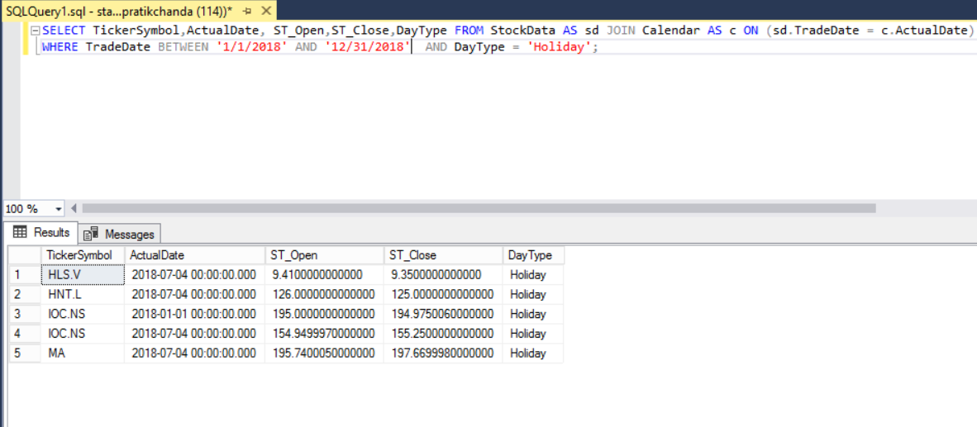

48. List every date that falls on a Friday from the Calendar table regardless of whether there are matching rows from the Stock Data table.

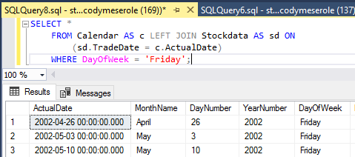

49. List the day of week and every date that falls on a weekend from the Calendar table and all rows from the Stock Data table.

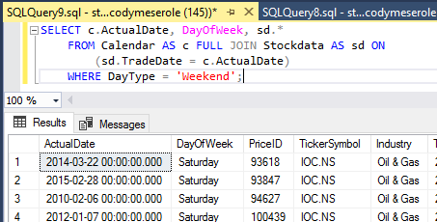

50. Remove all the rows of stocks of Microsoft that were traded during the month of October in the year 2017.

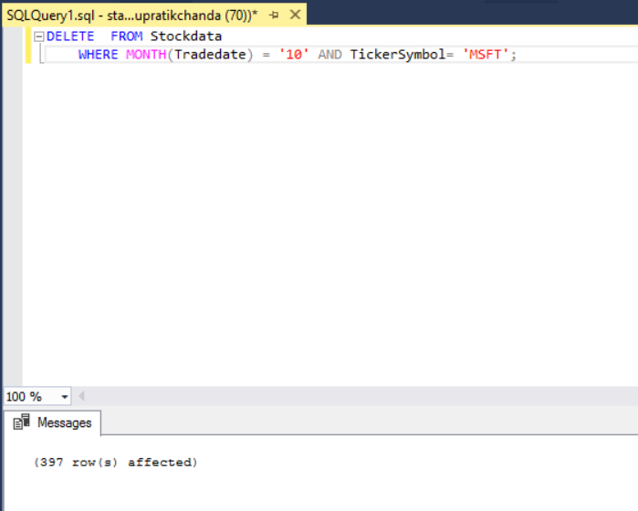

51. List the ticker symbol and the percentage of each ticker symbol's total number of trading days to the total number of days for all stocks.

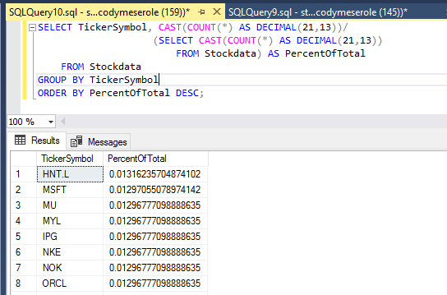

52. List the ticker symbol, the industry (only for the tech industry) , the row number and the closing stock price such that the highest prices are listed first and the lowest prices are listed last.

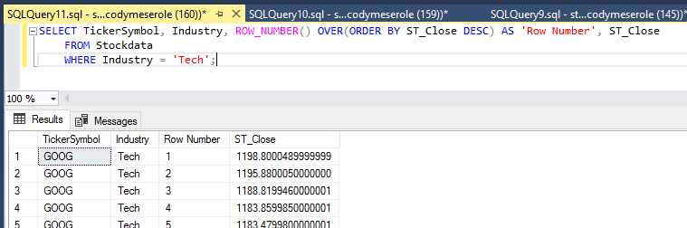

53. List the ten largest differences (from greatest to least) between a daily high and low stock price along with the accompanying TickerSymbol, Industry, and TradeDate.

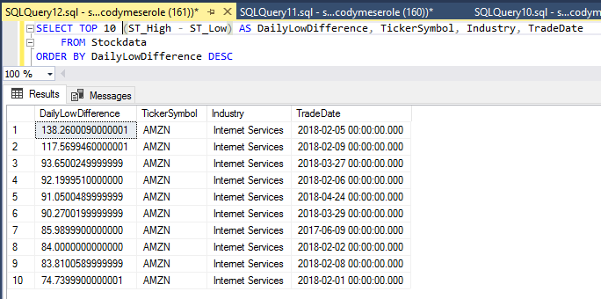

54. List each ticker symbol and the average daily trade volume for that stock. Order the list from highest to least daily trade volume.

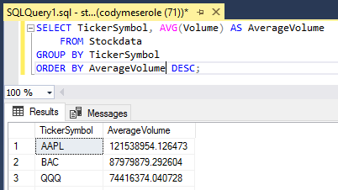

55. List each ticker symbol and the average daily trade volume for that stock on Fridays. Order the list from highest to least daily trade volume.

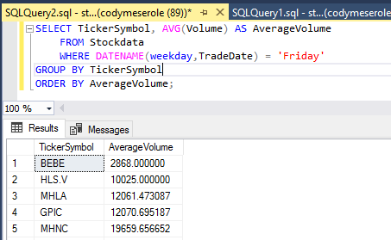

56. List each ticker symbol, day of the week, and the average daily trade volume for that stock on each day of the week. Order the list by ticker symbol and then by highest to least daily trade volume.

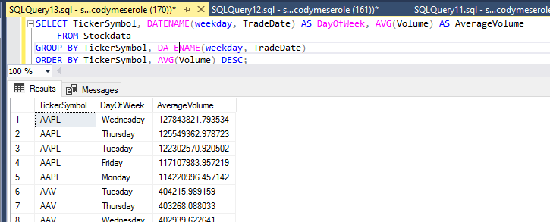

57. List the ten most common closing prices along with the number of times each occurs.

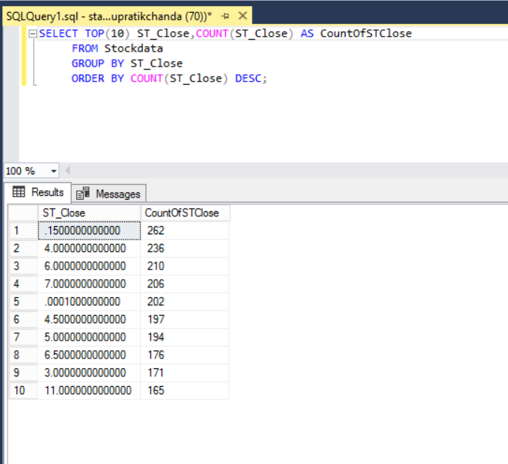

58. List all information from the rows sharing the single most common closing price.

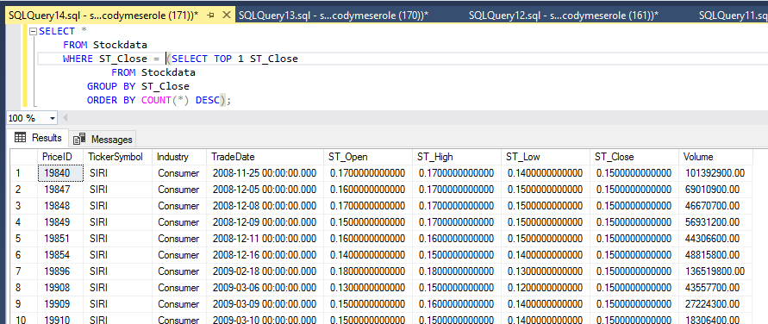

**Cleaning, Exploring, and Validating Data**

*When you are given a new data set, or when you load one into a database, it can be extremely helpful to verify that the data make sense before running any analytical queries. If you had just imported StockData, the following steps would be useful to explore the data.*

59. List 1000 rows of the table to see what the data look like. (On a production server, you would not select the entire table, but a limited number of rows. Otherwise you risk slowing down the server, particularly if the table is very large.)

*Note: this can also be done by right-clicking on the table name in SSMS and selecting “Select Top 1000 Rows”*

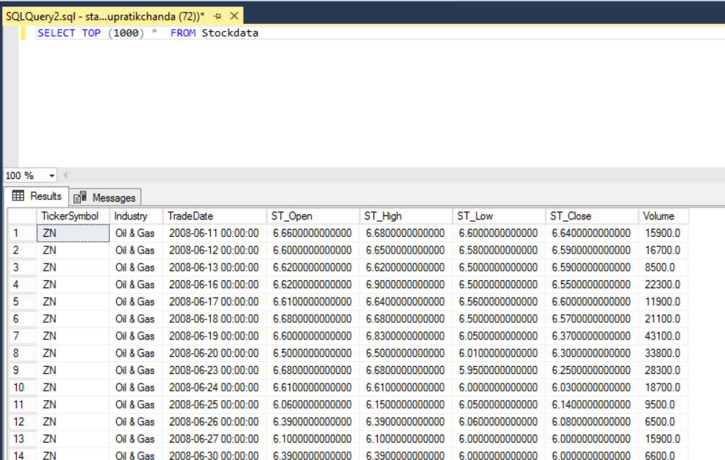

60. Look for missing data by listing any rows in StockData that contain nulls.

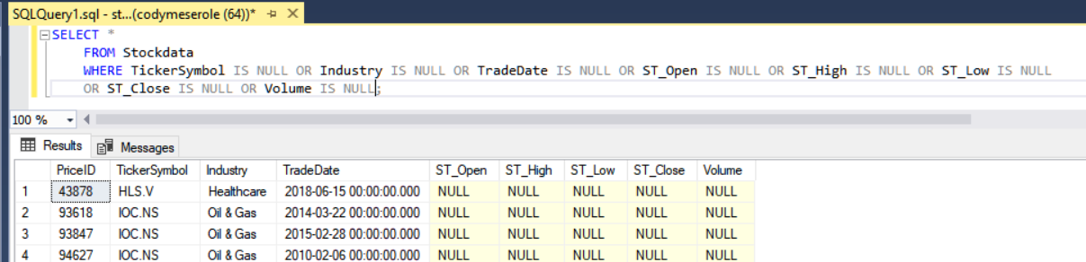

61. List the percentage of records containing nulls.

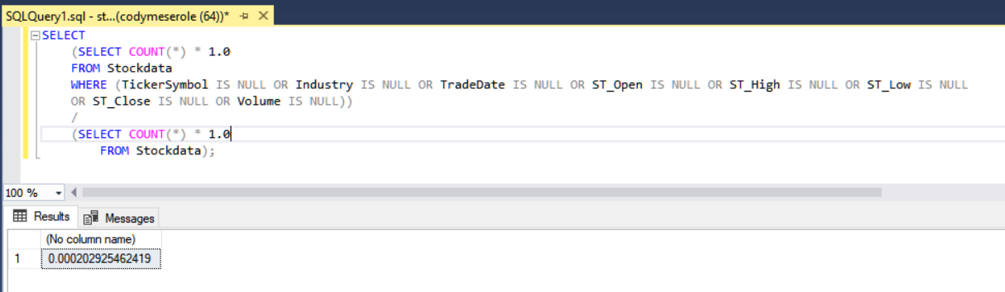

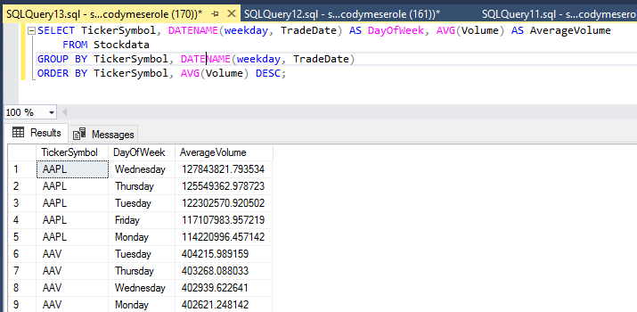

62. List all rows where the high stock price for the day is not at least as high as the low for that day. There should not be any rows where this is the case.

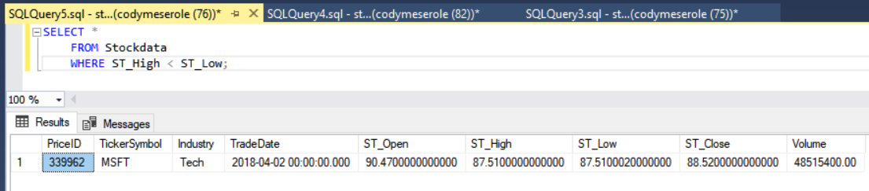

63. List all rows where any of the stock prices are zero.

*Stock prices should never be zero. These data are incorrect. The problem with leaving inaccurate data is that it will throw off other analyses (averages, etc.). If you found this data, you would have some options:*

* *Delete all rows with impossible (zero) values.*
* *Try to find the correct values and correct the records.*
* *Set the offending values to null, meaning you don’t know the correct value.*

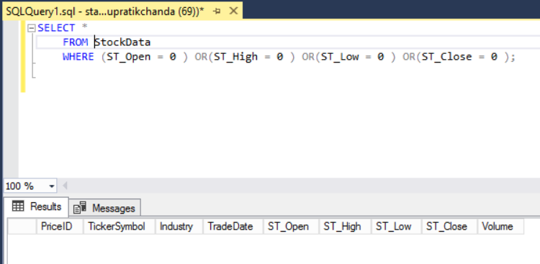

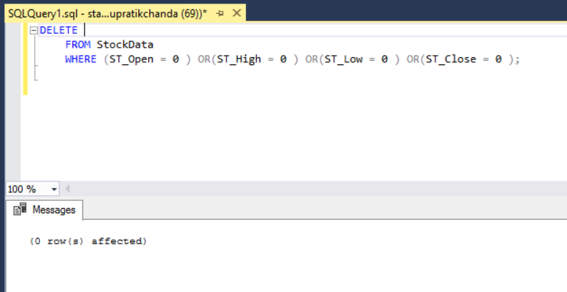

64. Set any opening stock prices that are zero to null.

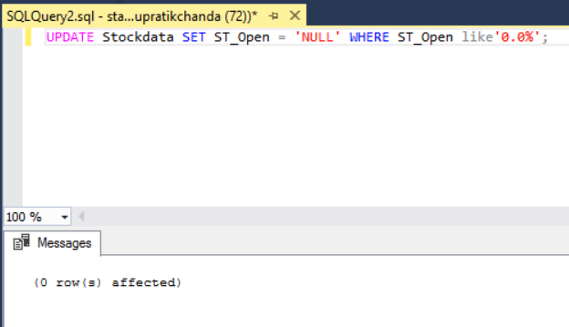

65. List the largest single-day stock **price** increase for Ford (between the market opening and closing).

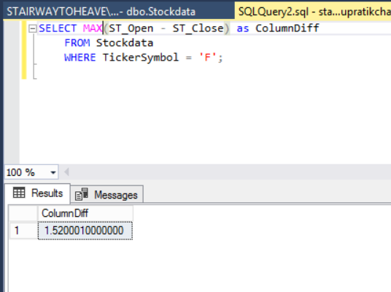

66. List the trade date and the amount the stock price increased for the day on which the price of Ford stock had the largest price increase.

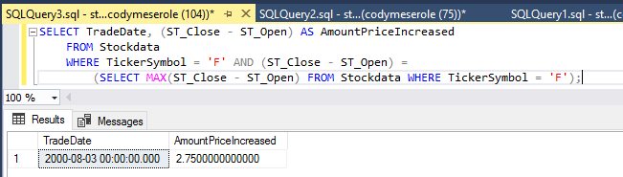

67. List the largest single-day stock price **percentage** increase for Ford (between the market opening and closing).

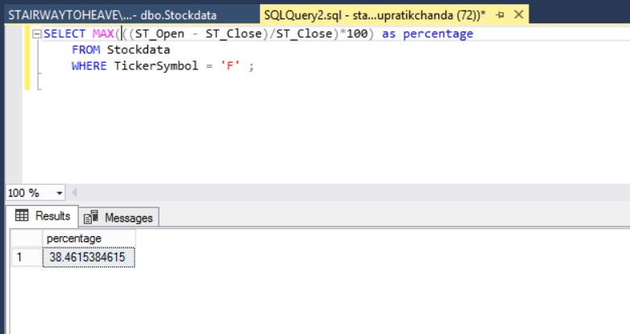

68. List the trade date and the percentage of the stock price increase for the day on which Ford stock had the largest percentage gain.

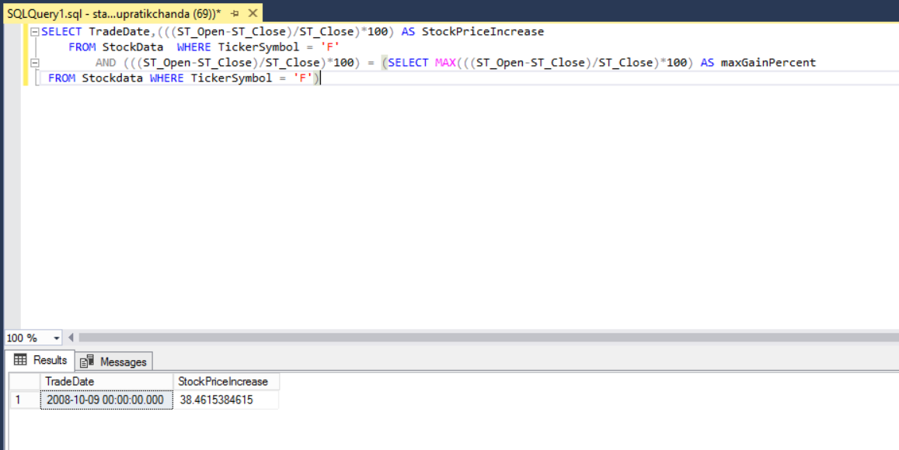

69. List the lowest opening price for Ford stock in 2017.

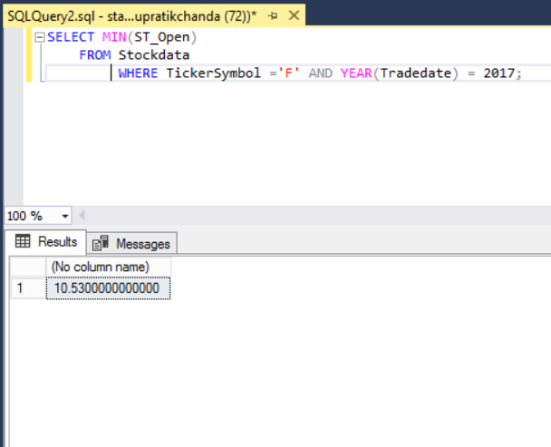

70. List the highest closing price for Ford in 2017.

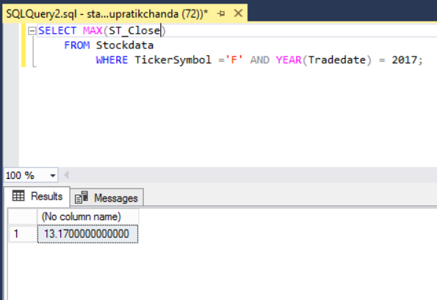

71. List the amount you would have made if you had purchased 1000 shares of Ford stock at its lowest opening price in 2016 and then sold it at its highest closing price in 2018.

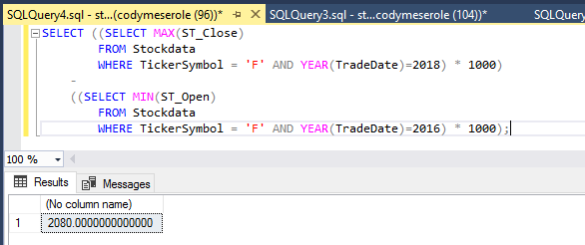

72. List the percentage increase that the above amount represents relative to the original investment.

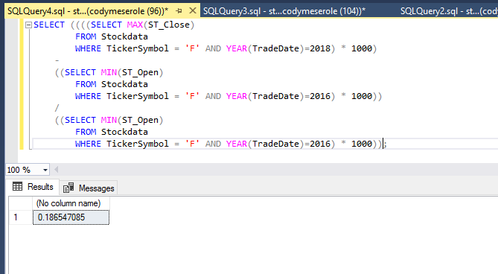

73. List the months of the year and their corresponding average closing prices of Ford stock. List the months with the lowest average closing prices first.

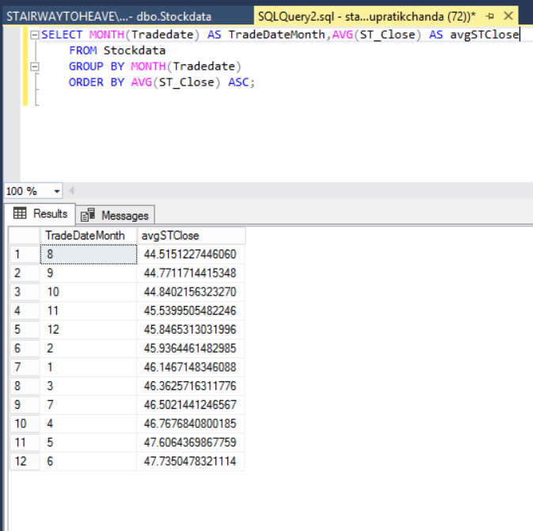

74. Suppose we have a theory that stocks dropped in value after September 11, 2001. List the minimum closing price of Ford stock in September 2001 before September 11.

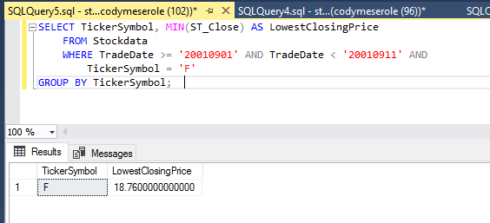

75. Now list the minimum closing price of Ford stock in September 2001 after September 11.

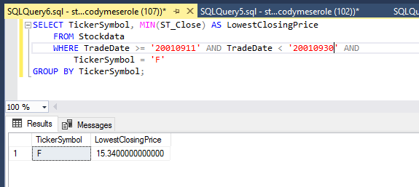

76. List the number of days in the table when a trade occurred (when the trade volume for any stock wasn’t zero).

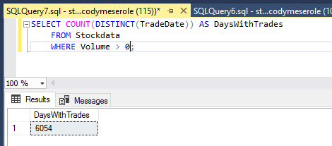

77. List the number of trade days in each month of 2017. Sort the list from least to greatest number of trade days.

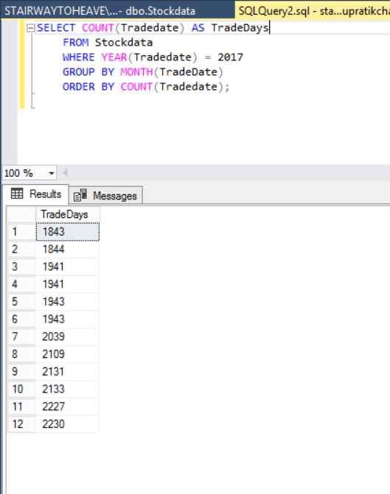

78. List the number of trade days in each month of 2017. Also include the average trade volume for each month. Sort the list from least to greatest number of trade days.

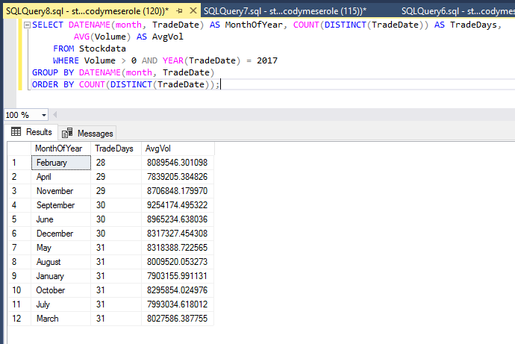

79. List the industries in alphabetical order and the number of companies in each industry in the table.

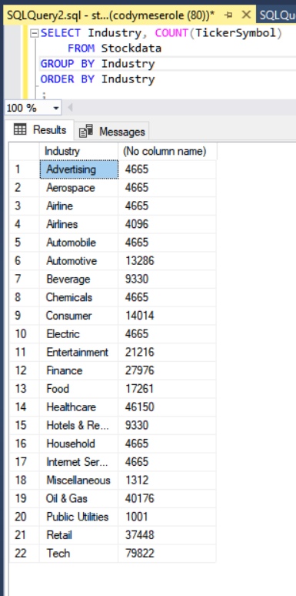

80. List the industries in alphabetical order and the number of companies in each industry in the table. Also include the range of dates and the number of unique dates for each industry.

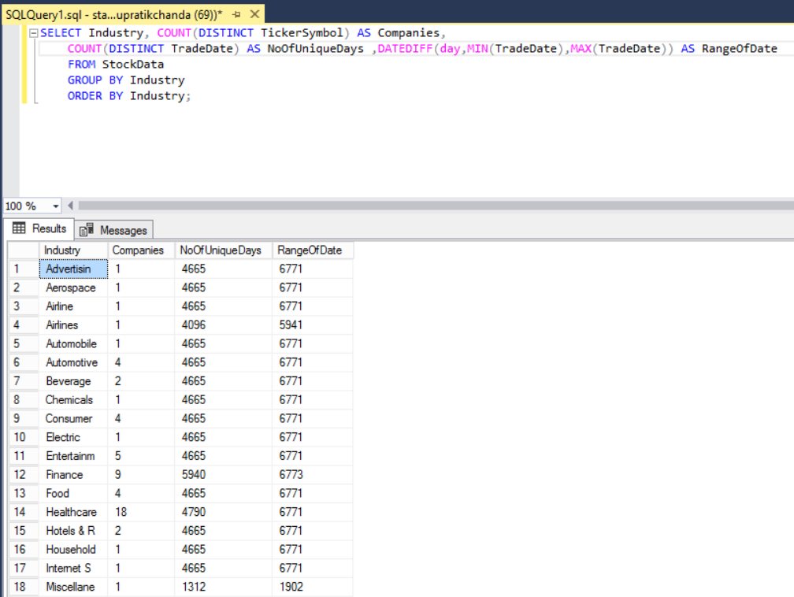

81. List the industries in alphabetical order and the number of companies in each industry in the table. Also include the ratio of unique dates to the range of dates for each industry.

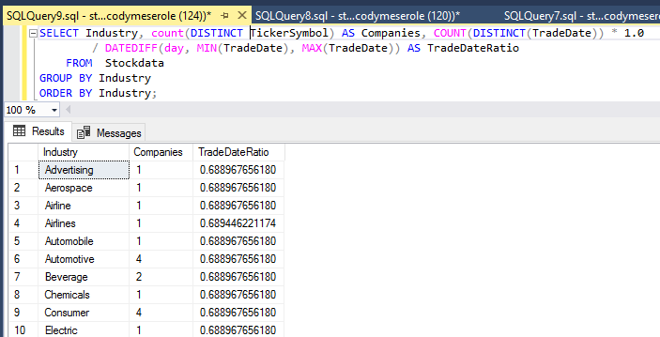

82. List the five rows with the highest ratio of daily high stock price to daily low stock price.

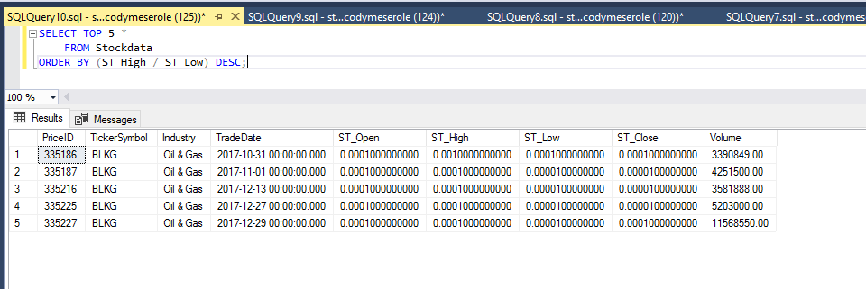

83. List the number of shares (including fractions of shares) you could have purchased with $2000 at the low price on the day when the high to low price ratio was highest.

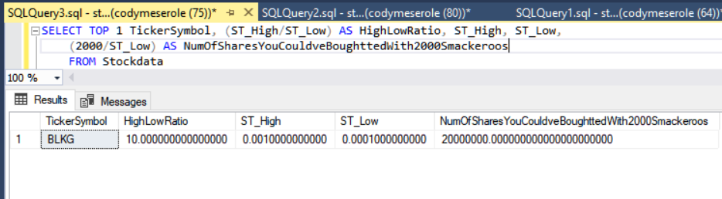

84. List the total selling price of the shares above if you sold them at the daily high price on the same day.

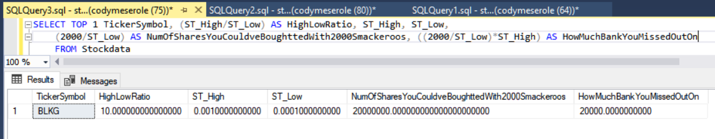

85. On October 9, 2008, you think the stock market is heading down so you panic and sell all of your stocks. If you had owned 200 shares of each stock in your table, list the amount you would have sold them for at the closing price on that date.

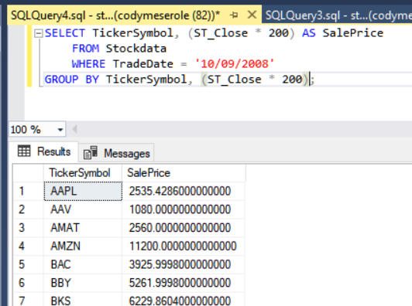

86. On October 9, 2012, you think the stock market is healthy and you decide to purchase your 200 shares of each stock back. How much will this cost?

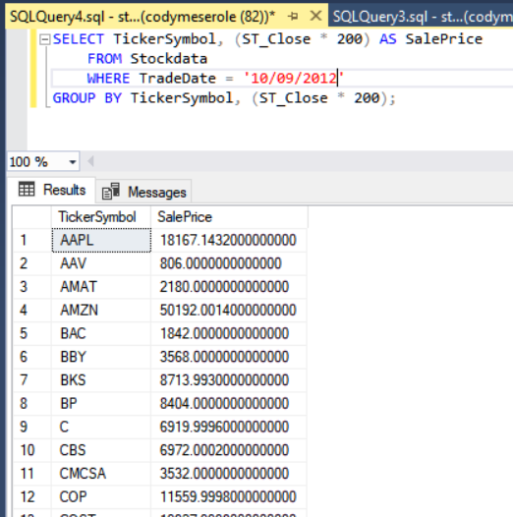

87. List the amount you made (or lost) by “wisely” selling when the market is struggling and buying when the market is “healthy.”

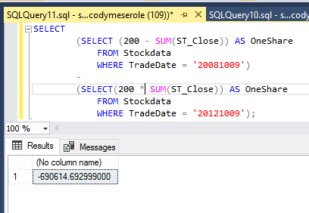

88. List all of the ticker symbols containing the letter S.

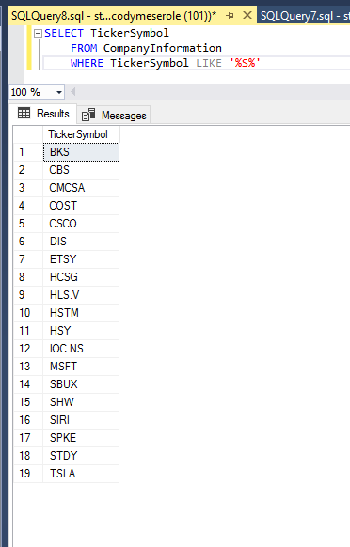

89. List the all of the ticker symbols containing the letter S and their average closing price in 2017.

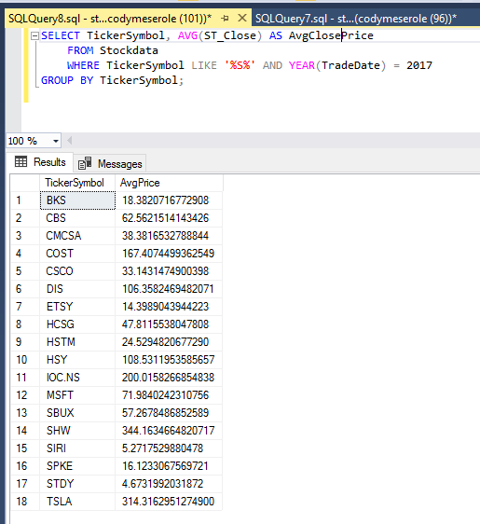

90. List the number of times you could have made at least a 10% profit by purchasing stocks at its lowest price for the day and selling the stock at its highest price for the day.

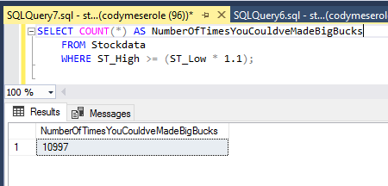

91. List the records on which you could have made at least a 10% profit by purchasing stocks at its lowest price for the day and selling the stock at its highest price for the day.

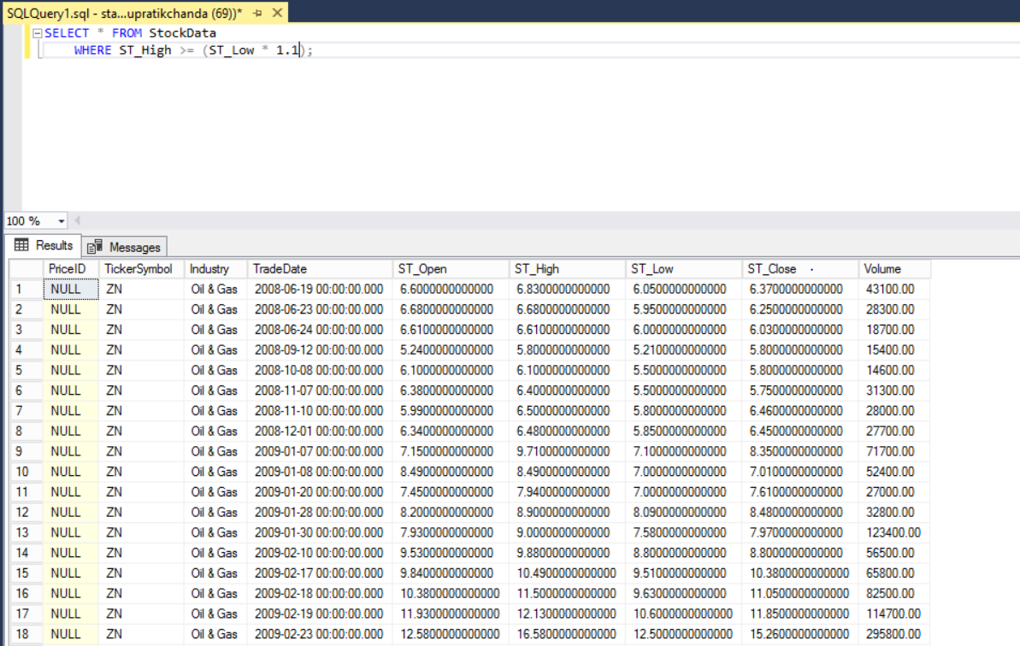

92. List the relevant ticker symbols and the number of times you could have made at least a 10% profit on that stock by purchasing the stock at its lowest price for the day and selling the stock at its highest price for the day. List the ticker symbol for which this occurs most frequently first.

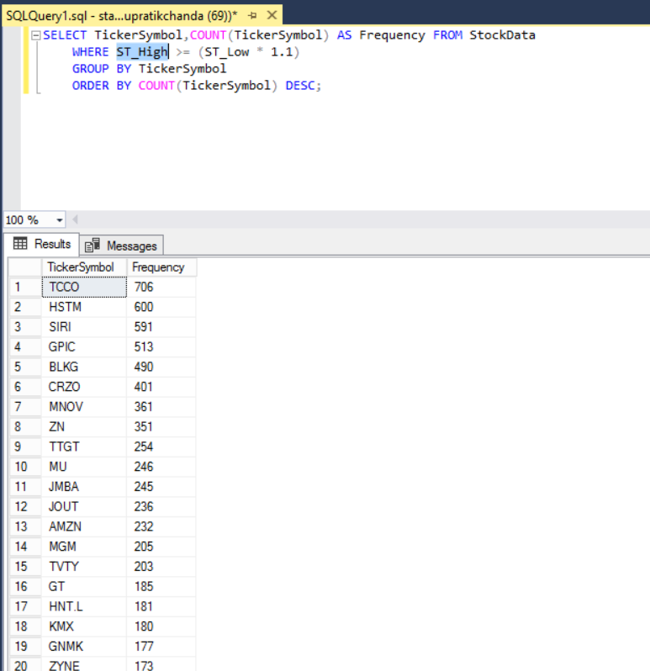

93. List the relevant ticker symbols and the number of times you could have had at least a 10% loss on that stock by purchasing the stock at its highest price for the day and selling the stock at its lowest price for the day. List the ticker symbol for which this occurs most frequently first.

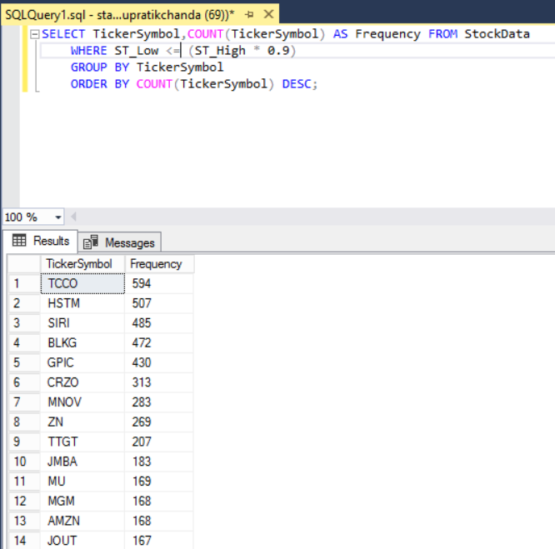

94. List the five rows with the highest price multiplied by volume. Use the closing price of as the price for the entire day.

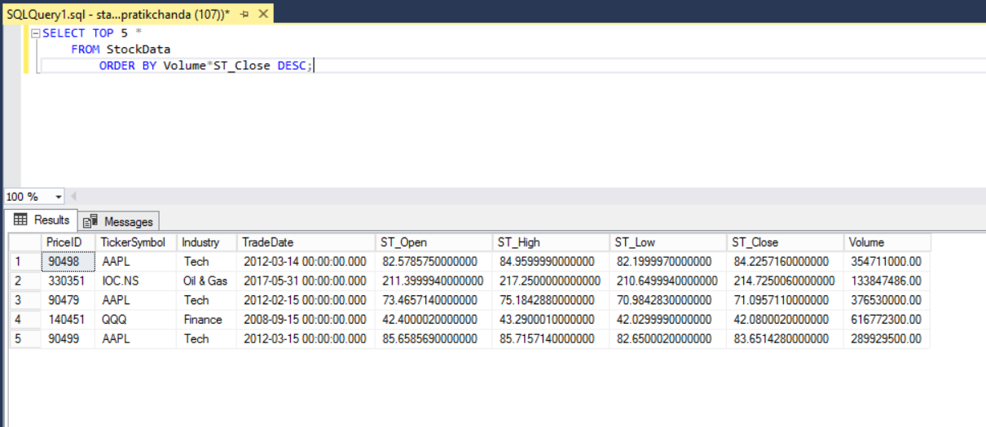

95. List the ticker symbols and the average price multiplied by volume for each ticker symbol in 2017. Use the closing price of as the price for the entire day. List the ticker symbol with the highest average price times volume first.

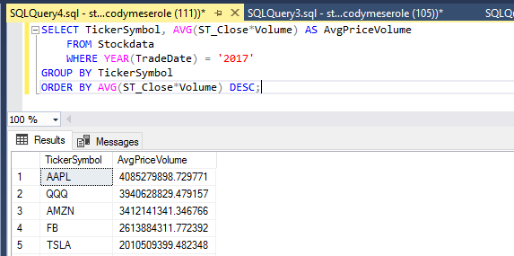

96. List the ticker symbol, year, and the average price multiplied by volume for each year for Apple stock. Use the closing price of as the price for the entire day.

